**Assignment-2**

**Python programming**

|  |  |
| --- | --- |
| **Assignment date** | **27th September 2022** |
| **Student name** | **Elakkiya M K** |
| **Student Roll Number** | **611219106021** |
| **Maximum Marks** | **2 Marks** |

**QUESTION:**

Build a python code, assume u get temperature and humidity values (generated with random function to a variable) and write a condition to continuously detect alarm in case of high temperature.

**CODE :**

import random

print ("welcome to me ")

temp=int(random.randint(0,100))

humid=int(random.randint(0,100))

if(temp>=1) and(temp<=20):

print (f"humidity level{humid}% cold breeze")

elif(temp>=21) and(temp<=29):

print (f"humidity level {humid}%, room temperature")

elif(temp>=30) and(temp<=54):

print (f"humidity level {humid}%, high temperature, switch on the AC ")

elif(temp>=-40) and(temp<=-1):

print (f"humidity level{humid}%, freezing")

else:

print ("humidity level 0%, house is burning")

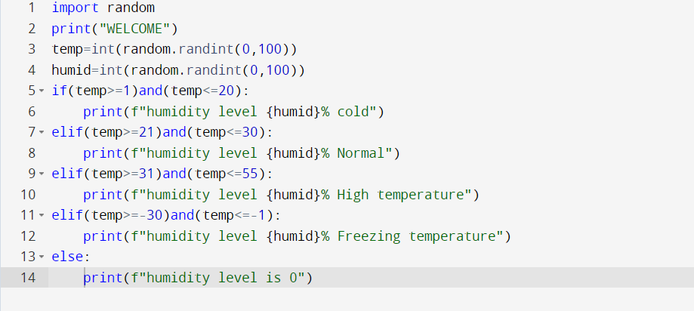

Output:

